AITeC

TASK 0

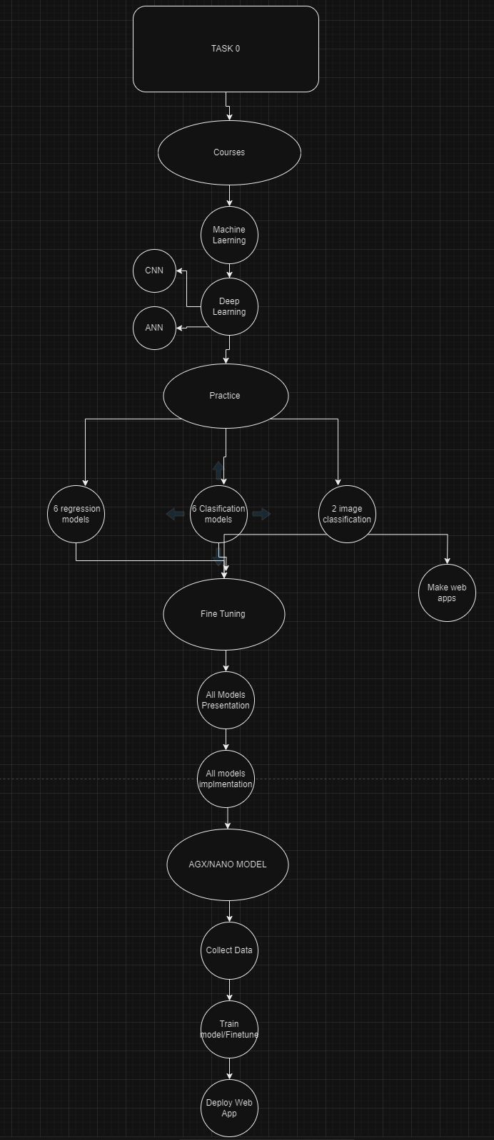

# Task A-Courses

## Machine Learning:

-Study all algorithms

-Presentation

* Intuition
* Code snippet
* Results

-Documentation

-Github

## Deep Learning:

### ANNs

-Study all algorithms

-Presentation

* Intuition
* Code snippet
* Results

-Documentation

-Github

### CNNs

-Study all algorithms

-Presentation

* Intuition
* Code snippet
* Results

-Documentation

-Github

# Task B-Assignment

## ANNs:

### Regression

-Practice 4 datasets

-Documentation

* Dataset description
* Table
* DatasetLink
* Model used
* Results

-Github

### Classification

-Practice 6 datasets

-Documentation

* Dataset description
* Table
* DatasetLink
* Model used
* Results

-Github

## CNNs:

-Practice 2 datasets

-Documentation

* Dataset description
* Table
* DatasetLink
* Model used
* Results

-Github

# Task C-Data Collection

-Collect Data

-Train Model

-Deploy WebApp